Materials and Methods in Teaching Mathematics PK-12
EDSP 413 Spring 2020
3 credits

Instructor:
Office Location:
Office Hours:
Office Phone:
Email:
Class Meeting Date and Time:

Course Description
EDSP 413: Methods and Adaptations for Teaching Mathematics (PK-12). (3) (Prereq: Admission to the Professional Program in Teacher Education) This course prepares candidates to teach mathematics, problem solving, and reasoning skills to students with mild to moderate disabilities PK - 12. The course focuses on national mathematics curriculum standards, research-based instruction, high-stakes assessment, functional mathematics, and problem solving with an emphasis on the effects of disabilities on mathematics achievement. The problem-solving strand extends to include cross-curricular applications of reasoning skills. S.

Intended Audience
Special Education majors, Junior II semester

Prerequisite(s)
Admission to the Professional Program in Teacher Education (PPTE)

Text/Other Required Materials/Resources
Stein, M., Kinder, D., Rolf, K., Silber, J. & Carnine, D. (2018). Direct instruction mathematics. (5th ed.). New York, NY: Pearson.

Individual Dry Erase Board, Dry Erase markers, Wipes for board

Moodle Course Management System: Used for reading assignments, handouts, syllabus, powerpoint presentations, grading, online assignments as needed.

National Council of Teachers of Mathematics (NCTM) Website:
http://www.nctm.org/
http://www.nctm.org/standards/

SC State Academic Content Standards
http://ed.sc.gov/agency/offices/cso/standards/math/

Math CBM Probes for use in the RtI model
http://www.interventioncentral.org/

Conceptual Framework
The overarching theme of the Conceptual Framework for all educator preparation programs is "The Educator as Reflective Practitioner." The initial and advanced teacher education programs and the advanced program in educational leadership focus on the development of knowledge, skills, and professional dispositions to ensure that all candidates are well prepared and meet all institutional, state, and professional standards at the completion of their program. The Conceptual Framework describes the shared vision of teaching, learning, and the preparation of teachers and school leaders. It outlines our philosophy and commitment to the education profession; guides programmatic decisions; and ensures coherence among curricula, field experiences, clinical practice, and the unit’s assessment system. The Conceptual Framework reflects our commitment to integrate technology, demonstrate professional behavior and dispositions, engage in reflective practice, work with diverse populations, and apply content and pedagogical knowledge to the teaching and learning process.

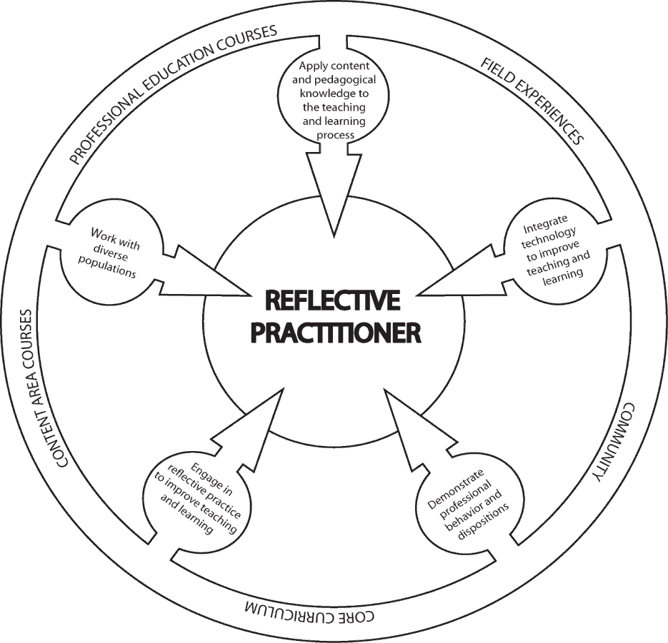

Spadoni College of Education’s Professional Behaviors and Dispositions addressed in this course: 4.1, 4.2, 4.3

Unit Assessments and SPA Assessments required of this course
EDSP 413 is part of the Mild to Moderate Special Education program that aligns with the requirements for teacher licensure/certification in South Carolina for Special Education: Multi-categorical PreK-12, as well as the Individualized General Curriculum standards established by the Council for Exceptional Children (CEC), the major special education professional organization in the United States. There is no required key assessment in this course.

Standards Alignment Information
CF= Conceptual Framework
CEC = Council for Exceptional Children (Specialized Professional Association (SPA) Content Standards
ADEPT = ADEPT Performance Standards (SC State Department of Education)
ISTE-E: International Standards for Teacher Educators/National Educational Technology Standards
InTASC = Interstate Teacher Assessment and Support Consortium

Student Learning Outcomes - Upon completion of this course, students should be able to:
1. provide an overview of mathematics reform movements since 1900 including the 1989 and 2000 NCTM standards' development and their impact on teaching and learning; | CF: 1.1  CEC: 6  ADEPT: 5ABC, 6ABC  InTASC: 4
2. demonstrate facility with the NCTM content and process standards across pre-K to 12 curriculum; | CF: 1.1  CEC: 6  ADEPT: 5ABC, 6ABC  InTASC: 4, 5
3. select or create, administer, and interpret informal mathematics assessments with students with disabilities; | CF: 1.5, 2.2  CEC: 4  ADEPT: 1AD, 2C, 3ABC, 7ABC  ISTE-E 6c, 7b  InTASC: 6
4. develop mathematics units of instruction that incorporate research-based strategies for students with disabilities; | CF: 1.2  CEC: 3  ADEPT: 1ABCDE, 2ABC, 6ABC  InTASC:5, 7, 8
5. select or create materials and technological applications appropriate for teaching mathematics concepts and use with students with disabilities; | CF: 1.3, 2.2  CEC: 3  ADEPT: 1AD, 2C, 3BC ,4C, 5B, 8C  ISTE-E 5abc  InTASC:5, 7, 8
6. integrate reasoning, communication, representation-making, and problem-solving skills within mathematics instruction; | CF: 1.1, 1.2  CEC: 5  ADEPT: 1ABCDE, 2ABC, 6ABC, 5ABC, 6ABC  InTASC:7, 8
7. integrate life skills and other content areas (literature, science, social studies) with mathematics instruction; and | CF: 1 1, 1.2  CEC: 5  ADEPT: 1ABCDE, 2ABC, 6ABC, 5ABC, 6ABC  InTASC: 7, 8
8. model positive dispositions about mathematics teaching and learning. | CF: 4.3  CEC: 2  ADEPT:  10ABCDE
9. focus on concrete, hands-on instruction and content presentation with an emphasis on real-world application and problem-solving. | CF: 3.1, 3.2,  CEC: 5  ADEPT: 3ABC, 5ABC, 6ABC, 7ABC, 8ABC  InTASC: 8
10. develop lesson plans that incorporates the knowledge and understanding of language, culture, family background influence learning and how to respond the individual differences in learning math. | CF: 1.2,3.2  CEC: 1,2,3,4,5,6  ADEPT:  1ABCDE, 2ABC, 6ABC,  3ABC, 5ABC, 6ABC, 7ABC  ISTE-E: 5abc, 7abc  InTASC:1, 2, 8

CCU Academic Integrity Code
Coastal Carolina University is an academic community that expects the highest standards of honesty, integrity and personal responsibility. Members of this community are accountable for their actions and are committed to creating an atmosphere of mutual respect and trust.

Honor Pledge (required of all entering CCU students)
On my honor, I pledge:
    - That I will take responsibility for my personal behavior; and
    - That I will actively oppose every instance of academic dishonesty as defined in the Code of Student Conduct.
From this day forward, my signature on any University document, including tests, papers and other work submitted for a grade is a confirmation of this honor pledge.

Attendance:
Students are expected to attend all parts of all classes, actively participate in all classes, demonstrate professional behavior in the classroom, and complete all assignments with professional quality and in a timely manner. When absence from class is unavoidable, students are responsible for getting all class information (e.g., handouts, announcements, notes, syllabus revisions) from another class member prior to the class meeting that follows the absence. A candidate who misses more than two classes will drop one letter grade. The grade of F will be assigned for absences in excess of 25% of the regularly scheduled class meetings.
Written documentation is needed to confirm any and all excused absences such as: a recognized emergency or from a serious illness. It is the responsibility of each student to assume the loss of instruction when not in attendance. It is also the sole responsibility of each student to obtain any missed instructional materials and/or notes. It is advisable that you designate another classmate to collect your materials in your absence. Please note that the Coastal Carolina University catalog states that an instructor is permitted to assign an F to a student with unexcused absences in excess of 25% of regularly scheduled class meetings. Please see the LiveWell@Coastal program for matters both personal and academic that may prevent you from completing your course responsibilities: https://www.coastal.edu/services/studenthealth/healtheducation/livewellccu/

Inclement Weather Policy for EDSP 413
In the event of hazardous weather, faculty, staff, and students are requested to listen to local radio and television stations or visit the Coastal Carolina University website for official University closing announcements. Announcements about hazardous weather are also posted on the University’s homepage. Review the Hazardous Weather and Emergency Conditions Leave Policy (FAST-HREO-220). Instructors may refer to the Contingency Instruction website or Section VIII N. Contingency Instruction for information about what to do if class has been cancelled. In the event that the university is closed due to poor weather conditions, log onto the Moodle Course page for EDSP 413. Remember to upload any assignments that are due for that session to avoid a deduction of points for lateness. Information will be available on our course Moodle indicating whether instruction will be provided online synchronously, asynchronously, or canceled altogether.

Support for Students with Disabilities

Coastal Carolina University is committed to equitable access and inclusion of individuals with disabilities in accordance with the Americans with Disabilities Act and Section 504 of the Rehabilitation Act. Individuals seeking reasonable accommodations should contact Accessibility & Disability Services (843-349-2503 or https://www.coastal.edu/disabilityservices/).

Student Services
Academic Support:
- Link to Learning Assistance Center
- Link to Kimbel Library Website
- Link to Counseling Services

Technology Support
- Link to Technical Support from Student Computing Services
- Link to A list of on-campus HelpDesks and the Help Request Form

Other Student Services
- Link to Office of the Registrar
- Link to Financial Aid and Scholarships
- Link to Student Activities and Leadership
- Link to Dean of Students Office

Course Objectives
EDSP 413 is designed to:
- prepare teacher candidates to teach mathematics, problem solving, and reasoning skills to students with high-incidence disabilities, PK - 12.
- focus on national mathematics curriculum standards, research-based instruction, high-stakes assessment, functional mathematics, and problem solving with an emphasis on the effects of disabilities on mathematics achievement.
- extend cross-curricular applications of reasoning skills to improve problem-solving skills.

Course Requirements/Grading

Grading: Grades will be based on the total points accumulated by the student. A total of 180 points are divided over the following course requirements:

Assessments | Maximum Point values
Professionalism | 15
Quizzes (4 @ 10 pts. Each) | 40
Midterm Exam | 25
Class Activities | 30
Strand Lesson Plans | 20
Math Resources Toolkit (5 @ 5 pts. Each) | 25
Final Exam | 25
Total Possible Points | 180

Course grades: Grades will be calculated as a percentage of possible points earned for course assignments and exams.

Grading Procedures (percentage of possible points)
A | 93-100% | C | 77-81%
B+ | 90-92% | D+ | 74-76%
B | 85-89% | D | 69-73%
C+ | 82-84% | F | 0-68%

Course Expectations & Assignments
- Professionalism: Candidates are expected to attend class and to be actively engaged in the course which will be evident by (a) asking questions, (b) participating in classroom discussions, (c) participating in group activities, and (d) being supportive of colleagues/peers
- Quizzes: Candidates will be given short quizzes over the course of the semester about what we have discussed in class and also about the reading assignments. A quiz may not be made up without a valid excuse.
- Midterm Exam: To be taken in class on a specified date. One attempt allowed.
- Strand Lesson Plan P: There are big ideas in mathematics that are recognized by the NCTM (Numbers & Operations; Algebra; Geometry; Measurement; Data Analysis & Probability). You will present a lesson based on the big ideas of math with a peer to the class. These presentations will be completed by candidates at all levels of mathematics instruction (PK-2, 3-5, 6-8, 9-12).
- Math Resources Toolkit: You will create a toolkit of evidence-bases strategies and resources to assist student learning in the area of mathematics. These are strategies for students (PK-12) to use. You will describe each strategy, manipulative, or other resource, where it was found, and with what age/grade it has been proven most effective. Your toolkit should contain at least five entries.
- Final Exam: To be taken in class or via Moodle on a specified date. One attempt allowed.
- Other class activities: Other class activities may include Math CBM probes, article reviews, identification and implementation of math strategies with peers.

Course Procedures
Class Engagement and Professional Dispositions:
As professional educators, your students are entitled to be served by professionals prepared with knowledge you will gain in this course. Students in this course are expected to conduct themselves in a professional manner in relationship to the opinions, ideas, and values of fellow classmates. Examples of in-class behaviors that are unprofessional include: (a) carrying on side conversations during class instruction and/or while another individual is speaking, (b) arriving late to class and disrupting others already engaged in the session’s activities, (c) attending class unprepared, causing a lack of meaningful participation and/or effort on the part of the student, and (d) texting/ emailing/browsing the internet during class.

Late Assignments: For each late assignment, ten percent of the total point value of the assignment will be deducted from the total points available per week after the due date until it is turned in. An assignment is considered "late" if it is not submitted by the time and date it is due. Dr. Miller will allow one assignment from each student to be submitted late without penalty. If you choose to use the late assignment option, it is then critical that you submit a document stating that you are using your one free late assignment. Then, the assignment MUST be submitted by the NEW due date which would be exactly one week from the original due date.

Example: Total possible points for assignment | 20
Earned score | 17
Submitted one class session late | -2 (10% of total possible score)
Final score | 15/20

Extra Credit: Please do not request extra credit work, as each assignment for this course was carefully designed to stimulate specific learning experiences among students that superfluous assignments cannot replace nor fulfill.

Communication with the Professor
✓ Routine access (daily) to CCU email and Moodle for communication and assignments is crucial to participation in this class.
✓ Please come see me in my office during office hours if we need to discuss anything.
✓ If your question can be solved through a simple email, please email me with the course name (EDSP 413) in the subject line. I should respond to you within 24 hours unless I am out of town at a conference which may cause a longer response time.

Course Outline
  - Perspectives
    - Direct Instruction
    - Curriculum Evaluation and Modifications
  - Basic Concepts and Skills
    - Counting
    - Symbol Identification
    - Place Value
    - Basic Facts
    - Addition
    - Subtraction
    - Multiplication
    - Division
    - Problem Solving
    - Measurement
    - Time
    - Money
  - Extended Concepts and Skills
    - Fractions
    - Decimals
    - Percents and Rations
    - Data Analysis
    - Geometry
    - Algebra
  - Lesson Planning and Assessment
Manipulatives List to be Used in this Course
- Base ten blocks
- Unit Cubes, Link-its, or Hundreds
- Cuisenaire Rods
- Fraction blocks or circles
- Algebra Tiles or Algeblocks
- Two-color counters, spinners, or dice
- Attribute blocks, Pattern blocks, or Geoboards
- Mirrors
- Fraction towers, decimal towers, percent towers
- Tangrams, Pentominoes

