3

Methods and Procedures for Teaching Students with Mild to Moderate Disabilities
EDSP 315
3 credit hours
Class sessions: T, TH 10:50 – 12:05 PM Meets in Prince 108

Professor:
Office:
Phone:
Email:
Office hours:

Intended Audience: Middle level majors
Prerequisite(s): Admission to PPTE

1.0 Course Description:

This course provides an in-depth study of characteristics associated with learning disabilities (LD), emotional/behavioral disorders (EBD), intellectual disability, (ID) and/or autism. Candidates in this course investigate service delivery, roles of various professionals, current trends, and philosophies related to persons with LD, EBD, ID, and/or autism. The selection and implementation of evidence-based instructional methods related to affective and learning behaviors and procedures for adapting materials to support students with mild to moderate disabilities in a variety of educational settings are addressed. Instructional settings, legal issues, ethics, and assessment regarding individuals with LD, EBD, ID and/or autism are addressed. (F)

EDSP 315 aligns with the requirements for teacher licensure/certification in South Carolina for Special Education: Multicategorical PreK-12, as well as the Individualized General Curriculum standards established by the Council for Exceptional Children (CEC), the major special education professional organization in the United States.

Text/Other Required Materials/Resources:
To be determined

Selected supplemental readings as assigned:
Readings will be assigned throughout the semester. They will typically be added as PDFs in the Moodle site for this class.

2.0 Conceptual Framework

The overarching theme of the Conceptual Framework for all educator preparation programs is "The Educator as Reflective Practitioner." The initial and advanced teacher education programs and the advanced program in educational leadership focus on the development of knowledge, skills, and professional dispositions to ensure that all candidates are well prepared and meet all institutional, state, and professional standards at the completion of their program. The Conceptual Framework describes the shared vision of teaching, learning, and the preparation of teachers and school leaders. It outlines our philosophy and commitment to the education profession; guides programmatic decisions; and ensures coherence among curricula, field experiences, clinical practice, and the unit’s assessment system. The Conceptual Framework reflects our commitment to integrate technology, demonstrate professional behavior and dispositions, engage in reflective practice, work with diverse populations, and apply content and pedagogical knowledge to the teaching and learning process.
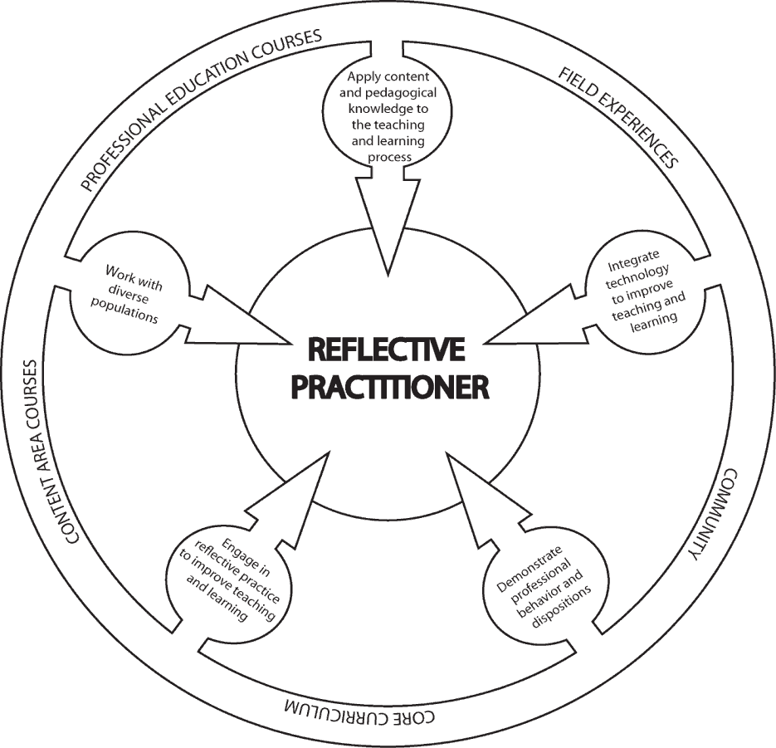

3.0 Unit Assessments and SPA Assessments required of this course:
No SPA assessments are required for this course; however, this course aligns with the standards for teacher licensure/certification in multicategorical special education established by CAPE and the Council for Exceptional Children (CEC), the major special education professional organization in the United States, which is the Specialized Professional Association (SPA) for special education.

Standards Alignment Information:
CF = Conceptual Framework & Candidate Proficiencies (2010)
CEC = Council for Exceptional Children [Specialized Professional Association (SPA)] Content Standards
ADEPT Performance Standards for classroom-based teachers InTASC = Interstate Teacher Assessment and Support Consortium ISTE-E = International Society for Technology in Education

Student Learning Outcomes | Alignment
Students who successfully complete EDSP 315 should be
able to:
1. Describe the impact of learning disabilities (LD), emotional/behavior disorders (EBD), intellectual disability (ID), and/or autism on instructional practices. | CF: 1.2, 3.1  CEC: 1,2,3,4,5,7  ADEPT: 1  InTASC: 1, 2,9
2. Apply data-based decision making to appropriate instruction utilizing universal design, differentiated instructional strategies, and positive behavioral supports. | CF: 1.1, 1.2, 3.2  CEC: 4,5,7  ADEPT: 1, 5  In TASC: 6, 7, 9  ISTE: 7
3. Identify and explain the basic components of systematic instruction for students with intellectual disability and/or autism and how these components differ from indirect instructional models | CF: 1.2, 3.1  CEC: 4, 5, 7  APS: 5, 6  InTASC: 3, 4, 8
4. Compare and contrast different instructional grouping techniques for students with disabilities | CF: 1.2, 1.3, 3.1, 3.2, 4.1  CEC: 4, 5, 7  ADEPT: 1, 5, 8
5. Incorporate prompting strategies into lesson plans to teach grade-level curriculum | CF: 1.2, 1.3, 3.1, 3.2  CEC: 2, 4, 5, 8, 10  APS: 9  InTASC: 4, 7, 10
6. Design instruction that provides access to the general curriculum for students with moderate disabilities | CF: 1.1,.1.2, 2.1, 3.1, 3.2  CEC: 3, 7, 10  APS: 1, 2, 4, 6, 10  InTASC: 4, 5, 6, 10  ISTE: 5, 7
7. Use assessment and evaluation results to select and evaluate instructional activities, monitor progress and modify interventions and learning environments. | CF: 1.1, 1.2, 3.1, 4.1  CEC: 3,4,5,9,10  ADEPT: 1, 2, 3  InTASC: 6
8. Prepare lesson plans that include instructional strategies and adaptations for students with mild to moderate disabilities in both general (math, science, social studies, English, etc.) and special education classroom environments. | CF: 1.1, 1.2, 1.3, 2.1, 3.1,  3.2, 4.1, 4.2, 4.3  CEC: 2, 3, 4, 5, 7  ADEPT: 1, 2, 6  InTASC: 1, 2, 3, 4, 5, 7, 8  ISTE: 5,7
9. Research effective practices in curriculum strategies that correspond with South Carolina Curriculum and Learning Standards, and the SC Education and Economic Development Act | CF: 1.2, 3.2, 4.3, 5.1  CEC: 3, 4, 7, 10  ADEPT: 1, 2, 5, 10  InTASC: 7, 8, 10
10. Use evaluation, planning and management procedures to match learner needs with instructional environments and methods, including accommodations and modifications | CF: 1.2, 1.3, 2.1, 3.1, 3.2,  4.1, 4.3  CEC: 3,4,5,7  ADEPT: 8, 9

Field Experience assigned to this course: EDSP 310 is assigned to this course. One or more assignments may require field components.

Policies

Academic Integrity Statement

Coastal Carolina University is an academic community that expects the highest standards of honesty, integrity and personal responsibility. Members of this community are accountable for their actions and are committed to creating an atmosphere of mutual respect and trust.

Honor Pledge: (required of all entering CCU students)
On my honor, I pledge:
    - That I will take responsibility for my personal behavior; and
    - That I will actively oppose every instance of academic dishonesty as defined in the Code of Student Conduct.
From this day forward, my signature on any University document, including tests, papers and other work submitted for a grade is a confirmation of this honor pledge.

Attendance:
Students are expected to attend all parts of all classes, actively participate in all classes, demonstrate professional behavior in the classroom, and complete all assignments with professional quality and in a timely manner. When absence from class is unavoidable, students are responsible for getting all class information (e.g., handouts, announcements, notes, syllabus revisions) from another class member prior to the class meeting that follows the absence. A candidate who misses more than two classes will drop one letter grade. The grade of F will be assigned for absences in excess of 25% of the regularly scheduled class meetings.

Written documentation is needed to confirm any and all excused absences such as: a recognized emergency or from a serious illness. It is the responsibility of each student to assume the loss of instruction when not in attendance. It is also the sole responsibility of each student to obtain and missed instructional materials and/or notes. It is advisable that you designate another classmate to collect your materials in your absence. Please note that the Coastal Carolina University catalog states that an instructor is permitted to assign an F to a student with unexcused absences in excess of 25% of regularly scheduled class meetings. Please see the LiveWell@Coastal program for matters both personal and academic that may prevent you from completing your course responsibilities: https://www.coastal.edu/services/studenthealth/healtheducation/livewellccu/

Inclement Weather Policy for EDSP 315 Closing of the University for Inclement Weather
In the event of hazardous weather, faculty, staff, and students are requested to listen to local radio and television stations or visit the Coastal Carolina University website for official University closing announcements. Announcements about hazardous weather are also posted on the University’s homepage. Review the Hazardous Weather and Emergency Conditions Leave Policy (FAST-HREO- 220). Instructors may refer to the Contingency Instruction website or Section VIII N. Contingency Instruction for information about what to do if class has been cancelled.

In the event that the university is closed due to poor weather conditions, log onto the Moodle Course page for EDSP 315 and check for any directions from Dr. XXX. Remember to upload any assignments that are due for that session to avoid a deduction of points for lateness.

Support for Candidates with Disabilities
Coastal Carolina University is committed to equitable access and inclusion of individuals with disabilities in accordance with the Americans with Disabilities Act and Section 504 of the Rehabilitation Act. Individuals seeking reasonable accommodations should contact Accessibility & Disability Services (843-349-2503 or https://www.coastal.edu/disabilityservices/).

Student Services
Academic Support:
Link to Learning Assistance Center Link to Kimbel Library Website Link to Counseling Services
Link to online orientation

Technology Support
Link to Technical Support from Student Computing Services
Link to A list of on-campus HelpDesks and the Help Request Form

Other Student Services
Link to Office of the Registrar
Link to Financial Aid and Scholarships Link to Student Activities and Leadership Link to Dean of Students Office

Course Objectives
This course is designed to prepare prospective teachers to:
    - Demonstrate evidence-based practices for teaching students with mild to moderate disabilities in the general and special curriculum that address national and state content standards, social skills, self-determination, self-advocacy, and school to post-secondary life.
    - Utilize evaluative data to develop and evaluate instructional strategies and adaptations appropriate for individuals in varied learning environments.
    - Design instruction that synthesizes knowledge of learning characteristics among individuals with an intellectual disability and/ or autism and systematic instructional procedures.
    - Apply prompting strategies to teach individuals with an intellectual disability and/or autism

6.0 Course Requirements/Grading

Grading: Grades will be based on the total points accumulated by the student. A total of --- points are divided over the following course requirements:

Assessments | Maximum Point values*
Application of Understanding (15)
Two exams (midterm and final) (2@ 30 pts.)
EBP Study Reports -- One for SLD, ID/Autism & 1 for EBD. (3 @ 15 pts.)
Instructional plan with prompting strategies
Adapted book and lesson

Application of EBP
Small group lesson plan
Homework
MAXIMUM POINTS POSSIBLE

*Point values subject to change as specific assessment tools are developed.

Course grades: Grades will be calculated as a percentage of possible points earned for course assignments and exams.

Grading Procedures (percentage of possible points)
A | 93-100% | C | 77-81%
B+ | 90-92% | D+ | 74-76%
B | 85-89% | D | 69-73%
C+ | 82-84% | F | 0-68%

Course Expectations & Assignments

Application or Understanding
Students will complete 15 Application or Understanding assignments. These assignments will allow the student to be either prepared to discuss class content or apply material that was covered in class. Examples of an Application or Understanding include reading guides, data sheets, and graphing module

EBP Study Reports: Candidates will read an article from a scholarly journal pertaining to an EBP. After reading the article, candidates will describe the study and explain the implications for instruction (See Appendix A for assignment format). The topics shall relate to instructional techniques, models, or interventions in various areas of providing services to students with LD, EBD, ID and/or Autism. The peer reviewed article must be approved by the instructor.

Application of EBP: Using the EBP selected in Part I of the assignment, candidates will prepare a one-page instructional strategy brief outlining how the practice could be utilized in multiple grade levels (e.g., early childhood, elementary, intermediate, middle level, secondary) with children who have disabilities. The final, errorless version will be uploaded to Moodle with open access availability for all peer colleagues (See Appendix B for assignment format).

Small Group Lesson Plan: Students will develop a lesson plan for a small group of students with mild to moderate disabilities. Students will use the template provided on Moodle.

Adapted Book: Students will select and adapt a grade-level book for learners with an intellectual disability at the middle school level. The teacher candidate will seek recommendations for appropriate books from course faculty and field experience teachers. Teacher candidates will adapt the book in terms of both material and content, as described in course lecture and course materials. Two copies of the book will be made and one will be provide to the grade-level classroom on which the book selection was based.

Lesson plan with prompting strategies:Teacher candidates will use a case study of a group of students develop a lesson plan to teach academic content to students with mild to moderate disabilities. The lesson plan will include appropriate modifications and adaptations to meet the needs of the case study students, including modifications to the curriculum, prompting strategies, and accommodations.

Homework Assignments: These will be due when you walk in the door. Assignments may be worth up to 5 points each. Generally, they will cover an article or website the course instructor has asked you to review and respond to in writing. See Appendix C.

Midterm and Final Examinations: A midterm and final examination will be administered at the mid-point and end the semester. MAKE-UPS WILL NOT BE GIVEN WITHOUT PRIOR APPROVAL.

  - Course Procedures

Class Engagement and Professional Dispositions:
As professional educators, your students are entitled to be served by professionals prepared with knowledge you will gain in this course. Students in this course are expected to conduct themselves in a professional manner in relationship to the opinions, ideas, and values of fellow classmates.
Examples of in-class behaviors that are unprofessional include: (a) carrying on side conversations during class instruction and/or while another individual is speaking, (b) arriving late to class and disrupting others already engaged in the session’s activities, (c) attending class unprepared, causing a lack of meaningful participation and/or effort on the part of the student, and (d) texting/ emailing/browsing the internet during class.

Late Assignments: For each late assignment, ten percent of the total point value of the assignment will be deducted from the total points available per week after the due date until it is turned in. An assignment is considered "late" if it is not submitted by the time and date it is due. Dr. XXX will allow one assignment from each student to be submitted late without penalty. If you choose to use the late assignment option, it is then critical that you submit a document stating that you are using your one free late assignment. Then, the assignment MUST be submitted by the NEW due date which would be exactly one week from the original due date.

Example:

Total possible points for assignment | 20
Earned score | 17
Submitted one class session late | -2 (10% of total possible score)
Final score | 15/20

Extra Credit: Please do not request extra credit work, as each assignment for this course was carefully designed to stimulate specific learning experiences among students that superfluous assignments cannot replace nor fulfill.

Communication with the Professor
    - Routine access (daily) to CCU email and Moodle for communication and assignments is crucial to participation in this class.
    - Please come see me in my office during office hours if we need to discuss anything.
    - If your question can be solved through a simple email, please email me with the course name (EDSP 315) in the subject line. I should respond to you within 24 hours unless I am out of town at a conference which may cause a longer response time.

Journals consulted and reviewed on a regular basis:

Behavior Disorders
Career Development for Exceptional Individuals Education & Treatment of Children
Exceptional Children
Focus on Exceptional Children
Intellectual and Developmental Disabilities Intervention in School and Clinic
Preventing School Failure
Journal of Applied Behavior Analysis
Journal of Autism and Developmental Disorders Learning Disabilities Quarterly
Remedial and Special Education
Teacher Education and Special Education TEACHING Exceptional Children
The Journal of Special Education

Additional Online Resources:
- South Carolina State Department of Education: http://ed.sc.gov
- Horry County Schools: http://www.horrycountyschools.net/
- Wrightslaw: www.wrightslaw.com
- LD Online: www.ldonline.org
- CEEDAR Center: http://ceedar.education.ufl.edu/
- Council for Learning Disabilities: https://council-for-learning-disabilities.org/
- American Institutes for Research (Special Education): http://www.air.org/focus- area/education/?id=9
- National Association of Special Education Teachers: http://www.naset.org/
- Council for Exceptional Children: www.cec.sped.org
- National Dissemination Center for Children with Disabilities: www.nichcy.org
- Center for Effective Collaboration and Practice: http://cecp.air.org/

Appendix A
EBP Study Report Format

This assignment should be written in APA format. It should include a cover page including Course Number, Course Name, Title of Assignment, and Student Name. Section headers should be included and all pages should be numbered.

Introduction: Provide an introduction to the paper. Describe what the research is about and explain its focus. State the EBP being examined in this study. State the hypotheses or research questions.

Methods (Paragraph 1): Identify the subjects in the study. Discuss who are the participants, where they are located, and other demographic data provided. Identify the procedures/methods used in the study. (e.g., design of study, how many subjects, what they did)

(Paragraph 2): Describe the variables and explain how each variable was measured. Be specific. Identify the name of the measurement and a brief description of each.

Results and Discussion: Discuss the results of the study. What did the authors learn from conducting the study? Did the data support or fail to support the stated hypotheses? You can find this information in the results and discussion section of the article.

Critique (at least 2 paragraphs): Critique the study. Specify what was done well and what could have been improved. Describe if you think the research was valuable. Explain if you believe the study was practical and/or helpful? If so, to whom? State if there should be more research conducted in this area. Describe to whom the results of this study apply. Make recommendations for next steps in this line of research.

 | Criteria | Points
Introduction | Describes what the research is about; explains its focus; includes the  EBP being examined; states the hypotheses or research questions | 5
Methods | Identifies the subjects in the study; describes the design of study; includes information on demographic data; states how many subjects; explains what they did; names the measurements used and  explains how each variable was measured | 5
Results and Discussion | Explains the results; describes what the authors learn from the  study; states whether the data support or fail to support the stated hypotheses | 5
Implications | What do the results of the study mean for teachers? For students? Has this practice demonstrated positive results for certain types of students? In certain types of settings? Do the limitations of the study make the results questionable? What else do we need to know about this practice that the study did not tell us? | 5

Appendix B Application of EBP
Article Reference: Summary of Article:

Connections and Application for use across Grade Levels for Children with Disabilities:
- Early Childhood

- Elementary

- Middle School

- High School

 | Criteria | Points
Format | Reference is provided for EBP; APA format is correct; paper  contain very few errors | 5
Summary | Includes the research question; includes a description of the EBP;  briefly describe the methods; describe the results; outlines the key findings of the study. | 5
Connections | Outlines how the EBP could be used in multiple grade level  classrooms with children with disabilities | 10

Appendix C

Homework Assignment Grading Rubric
Category | Grade Earned | General Description of Quality
Exemplary | 5 | Thoughtful, high-quality response; demonstrates detailed evidence of understanding; multiple details/examples provided; meets and exceeds all  requirements of assignment.
Satisfactory | 3 | Acceptable quality of response; demonstrates basic understanding; provides some details/examples; meets  all requirements of assignment
Below Expectations | 1 | Unacceptable quality of response; limited or no understanding demonstrated; few or no details/examples provided; does not meet all  requirements of assignment
No Submission | 0 | No assignment submitted

