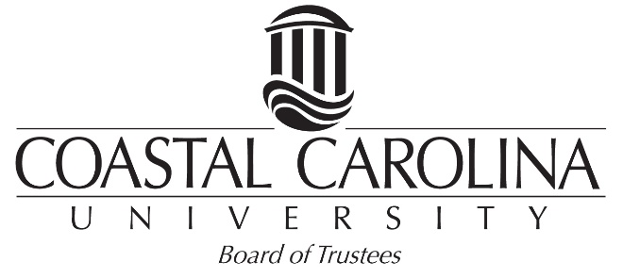

Advancement, Marketing, and Alumni Affairs Committee

April 16, 2018

TO: Mr. John H. Bartell Jr., Mr. Samuel H. Frink, Mr. Daniel W.R. Moore Sr.,
Mr. Oran P. Smith, Mr. Patrick S. Sparks and Mr. Samuel J. Swad

FROM: Mr. William E. Turner III

SUBJECT: Agenda

An Advancement, Marketing & Alumni Affairs Committee meeting will be held on Thursday, May 3, 2018 in the Wall Boardroom. The agenda will be as follows:

- Review and Approve February 15, 2018 Committee Minutes
- Office of Philanthropy Report
  - Financials – Giving Report
- July – April
- Endowment Campaign Update
  - Development Officers Updates
- Wall College of Business
- College of Humanities and CCU Retired Employees Group
- College of Science and College of Education
- Donor Relations/OLLI Development
- Women in Philanthropy and Leadership
- Marketing/Communications
- Teal 1000/Faculty Staff Campaign
- Mark Roach
C. Alumni Relations

- University Communications Report
A. Status Update – Bill Plate
B. Media & Public Relations Report – Martha Hunn
C. Marketing Report – Bill Plate
- Other Business

cc: Other Members of Board of Trustees

Dr. J. Ralph Byington
Dr. David DeCenzo
Mr. William M. Plate Jr.
Mr. Mark A. Roach
Mr. Todd Setzer

