Staff Senate 04/09/19

- Approval of Minutes
- Roll Call
- Special Order of the Day (if any)
- Senate President’s Report/Remarks
  - Public Meeting announcement
  - Metrics
    - Admissions Funnel
    - Enrollment & Registration
    - Budget, Pension, Healthcare, pay raise; state funds
- University President/Provost Remarks
- Presentation
  - Orientation – Freshman Registration
- Topics of Discussion
- Committee Reports
  - Student Pay Ad Hoc Committee – Alli Crandell
  - Take your child to work Committee – (Judy)
  - Policy and Welfare Committee – John Dooley (Salary Study, Student/Employee policy)
  - Membership Committee – Meg Hurt
  - Communication Committee – Judy Johns
- Staff Senate Affiliations – (SGA, Faculty Senate)
See list below
- Unfinished Business (Ongoing items carried over from a previous meeting)
- New Business (New items for consideration)
- Announcements / Good of the Order
- Next Meeting –
May 14, 2019
9am – Alford Ballroom

- Adjournment

Category : Facilities

Description : I feel that facilities charges an exorbitant amount for some of their services. The one in particular is painting. They painted a small section no bigger than a hand and charged over $100.00 for this. With limited funds, some departments can not afford this.

Prior Action : To my knowledge, there has been nothing done about this.

Suggestion : See if we can do a price analysis to see if these are the market rates for this labor.

Category : Parking

Description : As the use of electric vehicles continues to grow, we would like to see a few more EV charging stations added to campus. We currently have four, but two are also for student use, so often times, there aren't enough for everyone driving electric vehicles to campus.

Prior Action : No prior action taken.

Suggestion : Add two EV charging stations on the other side of campus as the four we have are currently near the dorms. Two possibly in the J lot adjacent to Singleton would be ideal.

Category: Shuttle Schedule
Description: I left my office at 4:10pm to catch the shuttle to the YY lot. The next bus did not come until 4:30pm. I did not get to my car in the YY lot until 4:52pm. It should not take 40 minutes for me to get to my car. The express shuttle that runs to YY lot stops at 4pm. Don’tyou tink it should run until at least 5:30pm so all staff can get to their car in a timely manner?

Category: Policy
Description: Campus wide lost & found policy
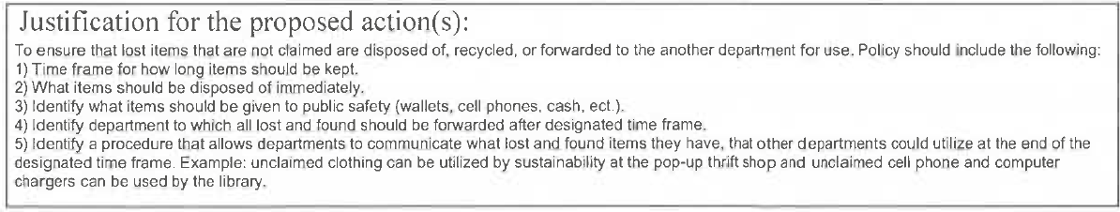

Category: Policy
Staff weekend pay differential
Initiate pay differential according to CCU HREO 224 and SC State HR regulation 19-705.07

