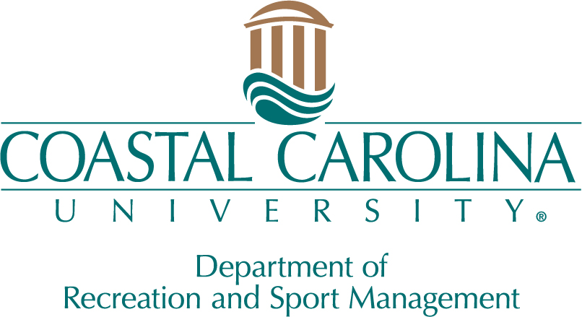
RSM Senior Banquet Awards
Outstanding Sophomore of the Year
This award is presented to the top Sophomore in the RSM department, recognized for their exceptional academic performance as reflected by their GPA (4.0).

Outstanding Junior of the Year
This award is presented to the top Junior in the RSM department, recognized for their exceptional academic performance as reflected by their GPA (4.0).

Minor of the Year
This distinguished award is granted to a standout student who is pursuing one of the following minors: Sport Studies or E-Sports.

Internship Merit Award
This award is presented to a graduating RSM senior who embodies professionalism, integrity, character, and consistently outstanding performance throughout their internship. Their contributions not only reflect positively on the department and college but also signify promising potential within the profession.

Nontraditional Student of the Year
This award is designed to honor a non-traditional RSM undergraduate student, who may have embarked on their college journey later than usual, balancing responsibilities such as employment or family care, having dependents to support, serving or having served in the armed forces, or being a veteran.

Teal Award
This award will be given to a RSM student who exemplifies a blend of the following attributes: encouraging, approachable, supportive, authentic, radiating positivity, and displaying resilience in navigating challenges.

Bronze Award
This award will be presented to a RSM student who encompasses any or all of the following traits: inspirational, motivational, friendly, helpful, genuine, possesses a positive attitude and the ability to overcome hardship.

Excellence in Recreation
This award honors a student who has made significant contributions and commitment to enhancing recreational experience at CCU.

Excellence in Sport
This award honors a student who has made significant contributions and commitment to enhancing sport and athletic experiences at CCU.

Graduate Assistant of the Year
This award is given to a senior graduate assistant who has demonstrated exemplary dedication and contributed significantly to a CCU department.

The following 2 awards are presented to an Undergraduate and Graduate Senior of the year
Given to one undergraduate/graduate student in each department at CCU, this award will be given to an RSM student who demonstrates academic achievement and epitomizes excellence in our field. This student will be recognized at the annual Spring Honors Convocation and will be eligible to receive the University-wide Outstanding Student award.

Teaching Associate of the Year
This award honors the achievements of an RSM adjunct/teaching associate who consistently demonstrates excellence in teaching, as selected by the students.

Faculty of the Year
This award honors the achievements of an RSM full-time faculty member who consistently demonstrates excellence in teaching, as selected by the students.

Young Alumni of the Year
This award is given to an RSM alumni who graduated in the past 5 years and is making significant contributions to the field.

Alumni of the Year
This award is given to an RSM alumni who graduated over 5 years ago and is making significant contributions to the field.

Spirit of the Chanticleer
This award is presented to an external partner who has shown genuine and consistent commitment to CCU’s RSM department.

