Spadoni College of Education
Coastal Carolina University

Course Syllabus for
EDUC 109 F1: Introduction to Peer Tutoring
Fall/Spring

Instructor | Jacklyn Masiello | Office | Prince 123 F
Dates | August 19- October 8 | Fax | 843-349-2670
Class Sessions | Tuesday & Thursday  4:30–5:45 p.m.,  Class will meet face to face on Thursday. | Phone | 843-349-2673
Class Location | Prince 107 | Email | jamasiell@coastal.edu
Office Hours | Monday- 2:00 p.m. -3:30 p.m.  Tuesday 9:00 a.m.-11:00 a.m.  Thursday- by appointment

Intended Audience: Students preparing to become Tutors or Mentors
Prerequisite(s): None

1.0 Course Description
EDUC 109 Introduction to Peer Tutoring (1 Credit) This course provides training in theory and tutoring strategies for individual and group peer tutoring. In addition, this course explores learning theory, learning styles, diversity, tutoring strategies, and group activities. This course is designed to meet eligibility requirements for the College Reading Learning Association (CRLA) – International Tutor Training Program Certification (ITTPC) for Certified Tutor, Level 1. F, S

2.0 Text/Other Required Materials/Resources
- Sanford, D. R, (2021). The Rowman & Littlefield Guide for peer tutors. Lanham, MD: Rowman & Littlefield
- IPad, laptop, or computer to access needed applications such as Moodle and email
The instructor will assign additional required readings and materials in addition to those listed on the course syllabus. All supplemental readings will be posted on Moodle.

3.0 Conceptual Framework
The overarching theme of the Conceptual Framework for all educator preparation programs is "The Educator as Reflective Practitioner." The initial and advanced teacher education programs and the advanced program in educational leadership focus on the development of knowledge, skills, and professional dispositions to ensure that all candidates are well prepared and meet all institutional, state, and professional standards at the completion of their program. The Conceptual Framework describes the shared vision of teaching, learning, and the preparation of teachers and school leaders. It outlines our philosophy and commitment to the education profession; guides programmatic decisions; and ensures coherence among curricula, field experiences, clinical practice, and the unit's assessment system. The Conceptual Framework reflects our commitment to integrate technology, demonstrate professional behavior and dispositions, engage in reflective practice, work with diverse populations, and apply content and pedagogical knowledge to the teaching and learning process.

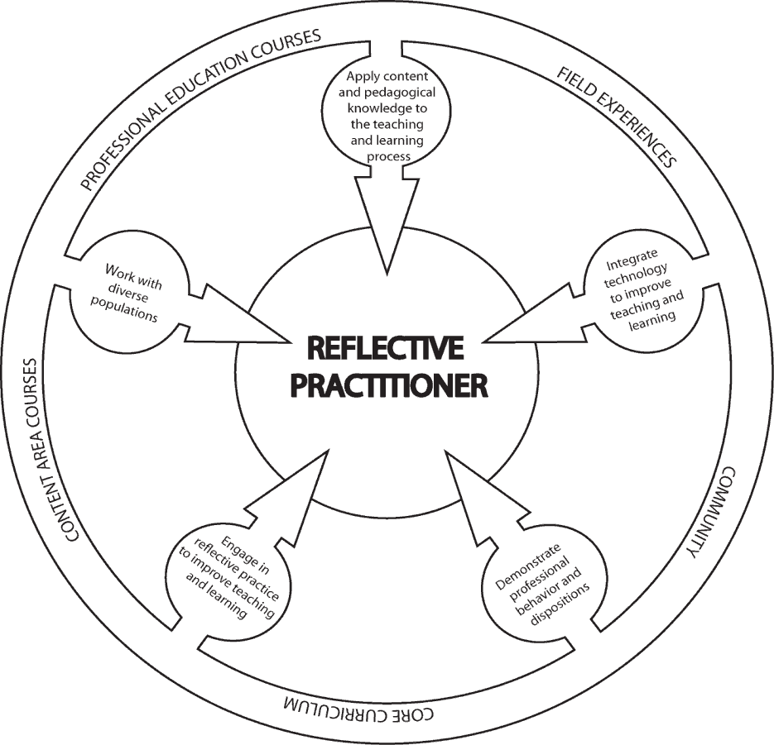

4.0 Course Objectives
Upon completion of this course, students will:
- Students will demonstrate knowledge of relevant learning theory.
- Students will broaden their understanding and awareness of how other people learn.
- Students will understand ethical concerns related to mentoring or tutoring and
how to handle difficult situations.

5.0 Course Structure
This course meets face-to-face.

7.0 Course Requirements
All assignments should be submitted by the due date and time indicated. All assignments should be typed, unless otherwise stated. For all assignments, please include the following info in the title of the document: Student Last Name, EDUC 109, and Title of Assignment. Students will upload assignments to Moodle, unless other directions are provided by the instructor. Every student must complete all assignments to pass this course.

8.0 Grading
The number of points out of a possible 100 will determine the grade earned by each student. The following table lists the distribution of available topics.
Assignment/Activity | Points
Attendance is mandatory, and  one must complete 10 hours of training. | 25 points
Pre & Post Test | 20 points
Syllabus Quiz | 5 points
Discussion Post (5 points per post) | 30 points
Observation Tutor Session (2 hours) | 30 points
7 Assignments  -What does being a peer tutor mean to you? -500 Word Essay  -The Penguin Video Reflection Quiz  -Navigating the Brain w/ Intellectual Disability Quiz  -Your Perspective Now? (essay, video, PowerPoint)  -Modifying student Assignment  -Strategy Organization Assignment  -Self-Determined Learning Model of Instruction | 140 points (20 points each)
Final Project | 50 points
Total | 300

Course Grades: The following table lists course grades and corresponding points earned.
A | 270-300
B+ | 252-269
B | 240-251
C+ | 225-239
C | 210-224
D+ | 195-209
D | 180-194
F | 179 or less

9.0 Course Assignments
9.1 What does being a peer tutor mean to you?
Students will write a 500-word reflection on what peer tutoring means to them.
9.2 The F.A.T. City Video & Reflection Quiz
Students will watch clips of F.A.T. City video and answer questions throughout the video using E.D. puzzle
9.3 Navigating the Brain w/ Intellectual Disability Quiz
Students will watch a video Simulation of Brain with a disability and answer quiz questions based on the lecture and video information.
9.5 Your Perspective Now? (essay, video, PowerPoint)
Students will describe their current perspective of an individual with a disability; what is the difference now versus before the course? How is a person with a disability perceived in other countries? Students may choose their platform in an essay, video, or PowerPoint.
9.6 Modifying student Assignment
Students will develop a modified assignment using a theorist's model discussed during the lecture for a LIFE student's assignment.
9.7 Strategy Organization Assignment
Students will create a graphic organizer about the material learned during weeks two and three, Learning the Brain.
9.8 Self-Determined Learning Model of Instruction
Students will create a Self-Determined Learning Model of Instruction (SDLM) based on how they want to tutor a LIFE student.
9.9 Students will create a tutorial video explaining the steps of a reoccurring problem they have
seen while tutoring.
9.10 Students will take a pre-test before the course starting and students take a post-test at the
end of the course session.

10.0 Course Policies and Procedures
Attendance and Participation:
Students are expected to attend class, to prepare for class by having read the assigned materials, to participate in class discussions, and to submit assignments on time. The grade of F will be assigned for absences in excess of 25% of the regularly scheduled class meetings.

Late Assignments: Late assignments will not be accepted.

Extra Credit: Please do not request extra credit, as each assignment for this course was carefully designed to stimulate specific learning experiences among students that additional credit assignments cannot replace or fulfill.

Cellular Phones and other portable electronic devices:
All devices should be turned silenced during class. If you need to keep your cell phone ringer on during the particular class session, please let me know prior to class beginning.

Inclement Weather Policy for EDUC 109
If the university is closed due to poor weather conditions, log onto the Moodle Course page for EDUC 109. Remember to upload any assignments due for that session to avoid a deduction of points for lateness. Information will be available on our course Moodle indicating whether the instruction will be online synchronously, asynchronous, or canceled.

Academic Integrity and Community Standards
Students are responsible for knowing and observing the Coastal Carolina University Code of Student Conduct requirements, the Statement of Community Standards, and the Honor Pledge.

Statement of Community Standards
Coastal Carolina University is an academic community that expects the highest standards of honesty, integrity, and personal responsibility/ Members of this community are accountable for their actions and reporting the inappropriate actions of others and are committed to creating an atmosphere of mutual respect and trust."

Honor Pledge (Required of all entering CCU students):
On my honor, I pledge:
- That I will take responsibility for my personal behavior.
- That I will actively oppose every instance of academic dishonesty as defined in the Code of Student Conduct.
From this day forward, my signature on any University document, including tests, papers, and other work submitted for a grade, is a confirmation of this honor pledge.

11.0 Support for Students with Disabilities:

Coastal Carolina University is committed to making reasonable accommodations for individuals with documented qualifying disabilities in accordance with the Americans with Disabilities Act of 1990 and Section 504 of the Rehabilitation Act of 1973. If you have a disability or believe that you need special accommodations, contact the Office of Accessibility and Disability Services.
PHONE: 843-349-2341
FAX: 843-349-5042
Accessibility Director: Emily Gaspar egaspar@coastal.edu
Assistant Director: Tiffany Long tlong1@coastal.edu
Accessibility and Disability Coordinator: Ebony McCrayemmccray@coastal.edu

12.0 Tentative Course Schedule:

Week | Date | Topic | Assignment
Week 1 | Thurs. August 19  Face-to-Face |  | -Pre-Test on Moodle (before class)  -Chapter 1 reading
 |  | What is Peer Tutoring? | -Question Reflection 500 words  -Discussion Post-1
Week 2 | Moodle-Tuesday  August 24 | Learning the Brain- Part 1 | -Chapter 2 & 5- reading  -The F.A.T. City Video Reflection Questions
 | Thursday  August 26 | Learning the Brian- Part1 | -Discussion Post 2
Week 3 | Moodle-Tuesday August 31 | Learning the Brain- Part 2 | -Navigating the Brain with an intellectual disability video-ED-puzzle
 | Thursday  September 2 | Learning the Brain- Part 2 | -Discussion Post 3
Week 4 | Moodle-Tuesday September 7 | Neurodiversity Linguistic & Cultural Diversity | -Chapter 7 reading  -Your Perspective Now? Video, Essay or Power Point  -Observations of Tutor Session
 | Thursday  September 9 | Neurodiversity Linguistic & Cultural Diversity | -Discussion Post 4
Week 5 | Moodle-Tuesday September 14 | Critical Thinking | -Chapter 8 reading  -Modify assignment using 1 theory for a LIFE student.
 | Thursday  September 16 | Critical Thinking | -Discussion Post 5
Week 6 | Moodle-Tuesday September 21 | Learning Strategies | -Chapter 6 reading  Use any Strategy to organize - Learning the Brain topics
 | Thursday  September 23 | Learning Strategies | -Discussion Post 6
Week 7 | Moodle-Tuesday September 28 | Application of Sessions | -Work on Final Project  -Observation of Tutor Session
 | Thursday  September 30 | Application of Session | -Self-Determined Learning Model of Learning Instruction
Week 8 | Tuesday  October 5 | Final | -Presentation of Final Project  -Post-Test on Moodle  -Tutorial of concept/concern-Video
 | Thursday  October7 | Final | -Presentation of Final Project  -Tutorial of Concept/Concern-Video

