Spadoni College of Education & Social Sciences
EDSC Course Syllabus

EDSC 546 Foundations of Secondary Education (3 credits)

Instructor | Austin M. Hitt II, Ph.D.
Office | 105H Prince Building
Office  Hours | Tuesday & Thursday 10:00 AM -12:00 PM & 3:00 PM -4:00 PM
Phone | 843-246-4196
E-mail | amhitt@coastal.edu

Course Name | Foundations of Secondary Education
Course ID & Section | EDSC 546 01
Credit Hours | 3
Semester/Year | Summer II
Location | Prince Building

Course Description
Course Description: A study of the principles of curriculum development in schools today as related to standards-based instruction and assessment. Attention is given to the teacher’s role in understanding curriculum, theory behind curriculum development, and implementing standards-based curriculum, instruction, and assessment.
Intended Audience: MAT teacher candidates
Prerequisite(s): Completed an undergraduate degree in content and admission to the M.A.T. program

Course Objectives
By the end of the course, students should have achieved the following learning outcomes:
- Articulate the historical and philosophical perspectives of curriculum in the United States.
- Articulate and employ the SC Academic Standards in one content area.
- Describe the key ideas and purpose for the South Carolina EEDA curriculum program.
- Analyze, articulate, and present to colleagues instructional decisions for teaching/learning a specific concept.

Required Text
None

Supplemental Texts
None

Course Requirements
- Desktop or laptop computer with Internet connection (high speed cable connection desirable), for use in online sessions and in between class meetings.

- All key assessments for your program will be uploaded to Chalk and Wire through your course’s Moodle page. This system is of no cost to students. It is expected that candidates will follow the instructions of their instructor as it relates to uploading key assessments to Chalk and Wire through Moodle.

- Skills
  - Ability to send email with file attachments
  - Ability to upload files to Moodle
  - Ability to view browser based multimedia

We are a community of professionals; as such, we hold all members of this community to high standards. When you participate in our courses, you are expected to be fully present. You should be dressed appropriately, in an environment free of distractions (e.g., not at work or in your bed), and prepared to engage with your colleagues with your video camera turned on.

Communication Policy
For general course questions, post to the General forum in Moodle or email instructor. I will also communicate announcements via this forum. As long as you stay subscribed to the forum, you will be notified via email whenever a new post is made. Questions posted to this forum should receive a response within 24-48 hours during the work week Monday-Friday. Feel free to answer questions posted by your classmates in the General forum. For specific questions related to your course work, email me at amhitt@coastal.edu. I will respond within 24 hours in most instances during the week. On the weekends, I will try to respond within 24-48 hours as scheduling/travel permits. You may call my office phone, but that just gets sent to my email, and I can respond to an email faster than phone call.

Grades for assignments and labs will be posted within two weeks after the due date in most circumstances.

Conceptual Framework
The overarching theme of the Conceptual Framework for all educator preparation programs is "The Educator as Reflective Practitioner." The initial and advanced teacher education programs and the advanced program in educational leadership focus on the development of knowledge, skills, and professional dispositions to ensure that all candidates are well prepared and meet all institutional, state, and professional standards at the completion of their program. The Conceptual Framework describes the shared vision of teaching, learning, and the preparation of teachers and school leaders. It outlines our philosophy and commitment to the education profession; guides programmatic decisions; and ensures coherence among curricula, field experiences, clinical practice, and the unit’s assessment system. The Conceptual Framework reflects our commitment to integrate technology, demonstrate professional behavior and dispositions, engage in reflective practice, work with diverse populations, and apply content and pedagogical knowledge to the teaching and learning process.

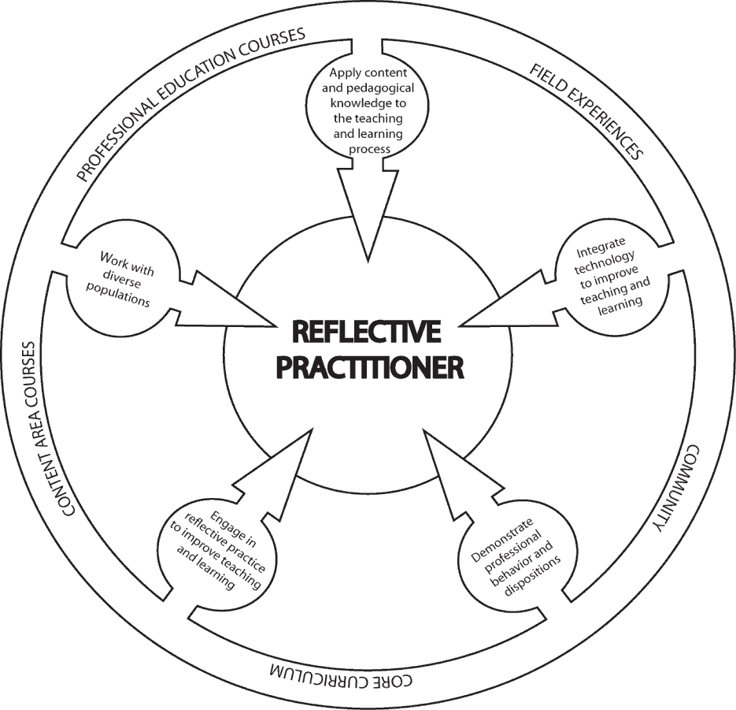

The Educator as Reflective Practitioner theme defines the initial and the advanced programs in educational leadership. The following candidate proficiencies are addressed and are reflected in program and course objectives:

1. Ability to apply content and pedagogical knowledge to the teaching and learning process
  - Demonstrate a thorough knowledge of subject matter and use such knowledge to create effective learning experiences for students (SCTS 4.0 #3, 9, 13).
  - Understand instructional planning and design plans based on knowledge of subject matter, students, community, curriculum goals, and standards (SCTS 4.0 #10, 13).
  - Use a variety of instructional strategies to encourage students’ development of critical thinking and problem solving skills (SCTS 4.0 #11, 12, 13).
  - Manage the classroom and school to create a positive and safe learning environment (SCTS 4.0 #16, 17, 18, 19).
  - Understand and use formal and informal assessment strategies to evaluate and monitor student learning, modify instruction, and create positive environments for student learning (SCTS 4.0 #15).

- Ability to integrate technology to improve teaching and learning
  - Plan and implement effective learning environments and experiences supported by technology (SCTS 4.0 #13).
  - Apply technology to facilitate effective assessment, evaluation, and productivity practices (SCTS 4.0 #15).

- Ability to work with diverse populations
  - Demonstrate knowledge of different cultural, emotional, developmental and cognitive needs of students (SCTS 4.0 #2, 10).
  - Evaluate, plan and provide appropriate activities and experiences to meet the needs of culturally and developmentally diverse student populations (SCTS 4.0 #2, 5, 10, 13).

- Ability to demonstrate professional behavior and dispositions
  - Demonstrate a commitment to the ideal of fairness* in the treatment of students based on their educational needs (SCTS 4.0 #16)
  - Demonstrate a belief that all students can learn and convey confidence and caring in working with students (SCTS 4.0 #18, 19).
  - Demonstrate professional dispositions and a commitment to fulfilling professional responsibilities (SCTS 4.0 Professionalism Standards #1-10).

- Ability to engage in reflective practice to improve teaching and learning
  - Analyze personal performance to improve teaching and learning (SCTS 4.0 Professionalism Standard #5, 6).
  - Analyze student performance to improve teaching and learning (SCTS 4.0 Professionalism Standard #8).

*Fairness (professional disposition): The commitment demonstrated in striving to meet the educational needs of all students in a caring, non-discriminatory, and equitable manner.

Student Learning Outcomes

The attached chart provides the student outcomes; alignment with university, state and national standards; and the assessment activities/requirements.

Student Outcomes  Students who successfully complete this course will be able to: | Standards Alignment Information | Assessment/Evaluation
Explain how the human brain produces thoughts, memories, and produces the condition of learning. | CF1.1  SCTS 4.0 #9, 13  INTASC 1, 2 | Video Lecture / Assessments  Midterm Examination
Apply emergent research within the field of cognitive science to planning and instruction. | CF 1.1. 1.3  SCTS 4.0 #9, 13  INTASC 1, 2, 5, 7, 8 | Non-content Teaching Presentation  Content Teaching Presentation  3 Day Unit Plan
Understand and discuss the connections between cognition (thought processing) and the research on motivation. | CF 1.1, CF 3.1  SCTS 4.0 #9  INTASC 1, 2, 3 | Video Lecture/Assessments  Midterm Examination
Apply pedagogical practices that are firmly grounded in cognitive science. | CF 1.1, 1.2, 1.3, 2.1, 2,2, 5.1, 5.2  SCTS 4.0 #2, 3, 5, 10, 11, 12, 13  INTASC 4, 5, 7, 8  ISTE 2.5a, 2.5b, 2.6a, 2.7.b | Non-content Teaching Presentation  Content Teaching Presentation  3 Day Unit Plan

Attendance Policy
In the Spadoni College of Education candidates are expected to demonstrate a commitment to high-quality work and excellence in professional practice. The following criteria should guide you in fulfilling your responsibilities.
Candidates must be present for each and every class and must take responsibility for keeping an accurate record of their absences. Professionally speaking, your principal will expect you to be in your classroom - everyday - unless an emergency or some other dire (and unforeseen) circumstance prevents you. The same standard applies in the Spadoni College of Education at CCU.

In this course it is impossible to be engaged in quality learning without taking these components seriously. Poor or late attendance, or not attending for full class time, may adversely affect your grade in the class. It is expected that students will refrain from scheduling any appointments during class time. When you are absent or tardy, you are missing components to the course that are difficult to recreate.

*According to CCU Policy, an instructor may assign the grade of F for unexcused absences exceeding 25% of the regularly scheduled class meetings – this is 2 classes. (See pages 43- 44 in the 2011-2012 Coastal Carolina University Catalog, available online.)

You are required to check your Coastal Carolina University E-Mail account daily for updated communications from your professors. Failure to do so could hinder your progress in both your education courses and practicum placements.
Asynchronous sessions: For reporting purposes, an absence in a distance learning course is operationally defined as a missed online submission deadline—such as a quiz, assignment, or discussion post. That means that, in a distance education context, documenting that a student has logged into an online class is not sufficient, by itself, to demonstrate attendance. A student must participate in some activity to be counted as having attended.
A general statement regarding illness, particularly as it relates to your field experience:
Please evaluate your own health status regularly and refrain from attending class and other on-campus events if you are ill. Students who miss class due to illness will be given opportunities to access the course online. You are encouraged to seek appropriate medical attention for treatment of illness. In the event of contagious illness, please do not come to class or to campus to submit work or meet with me. Instead, notify me by email about your absences as soon as possible, so that accommodations can be made. Please note that documentation for excused absences may be required. However, you should not come to class if you are feeling sick, even if you have not seen a doctor.

Academic Requirements
Projects and activities are required to be submitted when due. Ten percent will be deducted if work is not submitted on time, and each day work is late, including weekends and holidays. Work will not be accepted after five days from the due date. Additionally, your work must be of professional quality. It is expected that your work be clearly written and edited. Unedited work will result in a grade reduction. Remember to save a copy of all completed work. I am happy to review major assignments before the due date, but please note that they must be turned in to me at least 5 days before they are due for feedback.

Extra credit work or make-up work will not be provided at the end of the semester in the even that you are displeased with your grade. Please keep in mind that you are not entitled to an “A” by virtue of admission to the professional program; your grade in the course is earned.

It is recommended that students retain records of all course products to document their progress through the CCU Elementary Education program. Products from this class may be used to document your satisfactory progress through the CCU program and the ACEI performance based standards.

Course Assessments
A weighted grading system is used for this course. The categories of assignments are listed below.

- Class Attendance/Preparation/Participation (20% of final grade): Each class meeting will be worth 5 points,1 point for being on time, and 4 points for in class assignments.
- Midterm Examination (20% of final grade). This is an open-ended, outside-of-class examination.
- Pre-Class Online Lecture (10% of final grade)-For certain classes there will be required video lectures. The video lectures must be viewed and all connected questions answered prior to the face-to-face class meetings.
- Microteaching (30% of final grade): Candidates will prepare and teach (1) a non-technical lesson and (2) content- specific lesson to a small group of peers. Candidates will identify one concept and develop a 20 minute lesson. The lesson should include both teacher talk and some activity for the students (peers). After teaching a lesson, candidates will collect peer feedback and use this information to prepare a self- reflection of their performance.
- Three Day Unit Plan (20% of final grade): This assignment requires candidates to develop a learner-centered unit plan. First, each teacher candidate will choose a concept or concepts in his/her content area that aligns with the appropriate state standards.

Evaluation and Grading
Letter Grade | Points
A | 93 – 100%
B+ | 90 – 92%
B | 86 – 89%
C+ | 83 – 85%
C | 77 – 82%
D | 70 – 76%
F | 69% and below
*Candidates in the Professional Program in Teacher Education must earn the grade of "C" or above to continue in the program.

CCU Academic Integrity Code
Coastal Carolina University is an academic community that expects the highest standards of honesty, integrity and personal responsibility. Members of this community are accountable for their actions and are committed to creating an atmosphere of mutual respect and trust.

Honor Pledge: (required of all entering CCU students)
On my honor, I pledge:
- That I will take responsibility for my personal behavior; and
- That I will actively oppose every instance of academic dishonesty as defined in the Code of Student Conduct.
From this day forward, my signature on any University document, including tests, papers and other work submitted for a grade is a confirmation of this honor pledge.

Statement of Community Standards
Coastal Carolina University is an academic community that expects the highest standards of honesty, integrity and personal responsibility. Members of this community are accountable for their actions and are committed to creating an atmosphere of mutual respect and trust. Any class members who the instructor deems disruptive to the learning environment may be asked to leave class for the day.

Disability Statement
Coastal Carolina University is committed to equitable access and inclusion of individuals with disabilities in accordance with the Americans with Disabilities Act and Section 504 of the Rehabilitation Act. Individuals seeking reasonable accommodations should contact Accessibility & Disability Services (843-349-2503 or https://www.coastal.edu/disabilityservices/). Disabilities must be on record with the university in order for a student to be eligible for accommodations. This should be completed and the instructor should be notified during the first week of class.
Website: http://www.coastal.edu/disabilityservices ii. Phone number: 843.349.2341

Copyright
This course may contain copyright protected materials such as audio or video clips, images, text materials, etc. These items are being used with regard to the Fair Use doctrine in order to enhance the learning environment. Please do not copy, duplicate, download or distribute these items. The use of these materials is strictly reserved for this online classroom environment and your use only. All copyright materials are credited to the copyright holder.

Inclement Weather Statement
Closing of the University for Inclement Weather
In the event of hazardous weather, faculty, staff, and students are requested to listen to local radio and television stations or visit the Coastal Carolina University website for official University closing announcements. Announcements about hazardous weather are also posted on the University’s homepage. Review the Hazardous Weather and Emergency Conditions Leave Policy (FAST-HREO-220). Instructors may refer to the Contingency Instruction website or Section VIII N. Contingency Instruction for information about what to do if class has been cancelled.

Student Services
Academic Support:
Link to Learning Assistance Center
Link to Kimbel Library Website
Link to Counseling Services
Link to online orientation

Technology Support
Link to Technical Support from Student Computing Services
Link to A list of on-campus HelpDesks and the Help Request Form

Other Student Services
Link to Office of the Registrar
Link to Financial Aid and Scholarships
Link to Student Activities and Leadership
Link to Dean of Students Office

Course Schedule
Note: This schedule is tentative and subject to change.
Week, Day, Date | Targeted Concept or Skill | Assignments  All assignments without an asterisk are due before the start of the day’s class. Assignments with an asterisk (Thur. & Fri. online classes) are due before the start of class the following Monday.
W1-Monday | - Course Introduction | None
W1- Tuesday | - Associative Memory  - Schema  - Constructivism  - Perspective | None
W1-Wednesday | - Mental Models / Modeling  - Intuitive Theories  - Depth of Knowledge Illusion | Mental Models of the Physical World Video Lecture  Mental for the Social World Video Lecture
W1-Thur/Friday | - Physiological Needs (Maslow Level 1) | Sleep Video Lecture*  Hunger Video Lecture*
W2- Monday | - Safety & Security Needs  - Belonging & Connection Needs  - Depth of Knowledge Illusion  - Perspective Taking & Perspective Getting | Safety & Security Video Lecture  Belonging & Connection Video Lecture
W2-Tuesday | - Self-Esteem Needs | Self-Esteem Video Lecture
W2- Wednesday | - Cognitive Needs  - Extrinsic & Intrinsic Motivation  - Attention & Focus  - Scaffolding | None
W2-Thursday/Friday | Review of Previous Concepts | Midterm Examination*
W3- Monday | - Aesthetic Needs  - Creativity | None
W3-Tuesday | Microteaching (non-content) | None
W3-Wedesday | Microteaching (non-content) | None
W3-Thursday/Friday | - Microteaching Reflection | Micro-Teaching Reflection*
W4- Monday | - Lesson Planning | None
W4-Tuesday | - Micro-teaching (content) | Micro-Teaching Content
W4- Wednesday | - Micro-teaching (content) | Micro-Teaching Content
W4- Thursday/Friday | - Unit Plan  - Micro-teaching reflection | Lesson Plan and Content Micro-teaching reflection (Due by 12:00 PM Saturday August 7).

