Coastal Carolina University
EDSP 491 Instructional Procedures for Students with Learning Disabilities (3)
Spring 2021

Professor:
Office:
Phone:
Email:
Office Hours:

Course section, Meeting Days, Time, and Location:
Intended Audience: Special Education Majors
Prerequisite(s): Admission to PPTE

Course Description
This course provides knowledge of instructional procedures to improve outcomes for individuals with learning disabilities. Applies research on teacher effectiveness, instructional approaches, and current issues and needs in instructional programming for students with LD. Content includes curriculum design, instructional strategies for basic academic skills in reading, language arts, and mathematics; study skills and adaptations for science and social studies; motivation; and peer-mediated instruction. Experiences in schools and applied research projects required. S.

Course Text and Other Resources:

Insert text here

Conceptual Framework
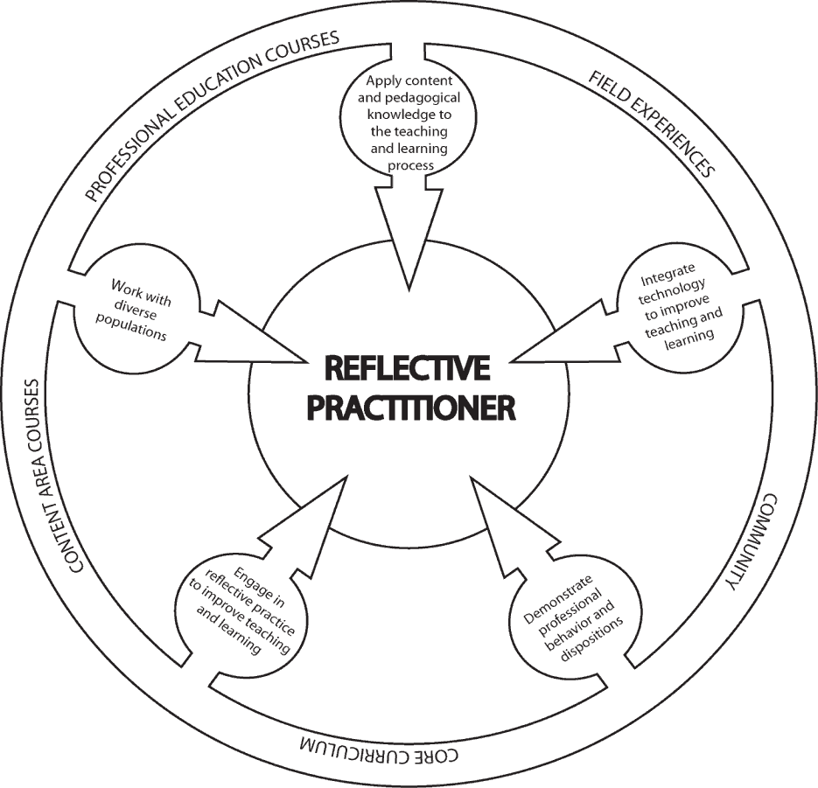
The overarching theme of the Conceptual Framework for all educator preparation programs is "The Educator as Reflective Practitioner." The initial and advanced teacher education programs and the advanced program in educational leadership focus on the development of knowledge, skills, and professional dispositions to ensure that all candidates are well prepared and meet all institutional, state, and professional standards at the completion of their program. The Conceptual Framework describes the shared vision of teaching, learning, and the preparation of teachers and school leaders. It outlines our philosophy and commitment to the education profession; guides programmatic decisions; and ensures coherence among curricula, field experiences, clinical practice, and the unit’s assessment system. The Conceptual Framework reflects our commitment to integrate technology, demonstrate professional behavior and dispositions, engage in reflective practice, work with diverse populations, and apply content and pedagogical knowledge to the teaching and learning process.

Unit Assessments and SPA Assessments

No SPA assessments are required for this course; however, this course aligns with the standards for teacher licensure/certification in special education established by CAPE and the Council for Exceptional Children (CEC), the major special education professional organization in the United States, which is the Specialized Professional Association (SPA) for special education.

Standards Alignment Information:

CF = Conceptual Framework & Candidate Proficiencies (2010)
CEC = Council for Exceptional Children [Specialized Professional Association (SPA)] Content Standards
APS=ADEPT Performance Standards for classroom-based teachers
InTASC = Interstate Teacher Assessment and Support Consortium
ISTE-E = International Society for Technology in Education

Student Learning Outcomes | Alignment
Students who successfully complete EDSP 491 should be
able to:
- Use assessment and evaluation results to select and evaluate instructional activities, monitor progress and modify interventions and learning environments | CF: 1.1, 1.2, 3.1, 4.1 CEC: 3,4,5,9,10  APS: 1, 2, 3  ISTE- E 7  INTASC 6
- Identify instructional methodologies that research has supported as effective for many students with learning disabilities | CF: 1.2, 3.2, 4.3, 5.1 CEC: 3, 4, 7, 10  APS: 1, 2, 5, 10  INTASC 4
- Develop and adapt lessons that support students with learning disabilities. | CF: 1.1, 1.2, 1.3, 2.1, 3.1, 3.2, 4.1, 4.2, 4.3 CEC: 2, 3, 4, 5, 7  APS: 1, 2, 6  ISTE-E 5  INTASC 7, 8
- Compare and contrast different instructional grouping techniques for students with learning disabilities | CF: 1.2, 1.3, 3.1, 3.2, 4.1  CEC: 4, 5, 7  APS: 1, 5, 8  INTASC 3, 4
- Use evaluation, planning and management procedures to match learner needs with instructional environments and methods, including accommodations and modifications | CF: 1.2, 1.3, 2.1, 3.1, 3.2,  4.1, 4.3  CEC: 3,4,5,7  APS: 8, 9  INTASC 2, 3

Field Experience assigned to this course: There is no field experience connected to this course. However, one or more assignments may require pre-service candidates to work with children and/or teachers in an educational setting.

Policies
Academic Integrity Statement
Coastal Carolina University is an academic community that expects the highest standards of honesty, integrity and personal responsibility. Members of this community are accountable for their actions and are committed to creating an atmosphere of mutual respect and trust.

Honor Pledge: (required of all entering CCU students)
On my honor, I pledge:
    - That I will take responsibility for my personal behavior; and
    - That I will actively oppose every instance of academic dishonesty as defined in the Code of Student Conduct.
From this day forward, my signature on any University document, including tests, papers and other work submitted for a grade is a confirmation of this honor pledge.

Attendance
Students are expected to attend all parts of all classes, actively participate in all classes, demonstrate professional behavior in the classroom, and complete all assignments with professional quality and in a timely manner. When absence from class is unavoidable, students are responsible for getting all class information (e.g., handouts, announcements, notes, syllabus revisions) from another class member prior to the class meeting that follows the absence. A candidate who misses more than two classes will drop one letter grade. The grade of F will be assigned for absences in excess of 25% of the regularly scheduled class meetings.
Written documentation is needed to confirm any and all excused absences such as: a recognized emergency or from a serious illness. It is the responsibility of each student to assume the loss of instruction when not in attendance. It is also the sole responsibility of each student to obtain and missed instructional materials and/or notes. It is advisable that you designate another classmate to collect your materials in your absence. Please note that the Coastal Carolina University catalog states that an instructor is permitted to assign an F to a student with unexcused absences in excess of 25% of regularly scheduled class meetings. Please see the LiveWell@Coastal program for matters both personal and academic that may prevent you from completing your course responsibilities: https://www.coastal.edu/services/studenthealth/healtheducation/livewellccu/
Inclement Weather Policy for EDSP 491
In the event of hazardous weather, faculty, staff, and students are requested to listen to local radio and television stations or visit the Coastal Carolina University website for official University closing announcements. Announcements about hazardous weather are also posted on the University’s homepage. Review the Hazardous Weather and Emergency Conditions Leave Policy (FAST-HREO- 220). Instructors may refer to the Contingency Instruction website or Section VIII N. Contingency Instruction for information about what to do if class has been cancelled.

In the event that the university is closed due to poor weather conditions, log onto the Moodle Course page for EDSP 491 and check for any directions from Dr. Miller. Remember to upload any assignments that are due for that session to avoid a deduction of points for lateness.
Support for Candidates with Disabilities

Coastal Carolina University is committed to equitable access and inclusion of individuals with disabilities in accordance with the Americans with Disabilities Act and Section 504 of the Rehabilitation Act. Individuals seeking reasonable accommodations should contact Accessibility & Disability Services (843-349-2503 or https://www.coastal.edu/disabilityservices/).

Student Services
Academic Support:
Link to Learning Assistance Center Link to Kimbel Library Website Link to Counseling Services
Link to online orientation

Technology Support
Link to Technical Support from Student Computing Services
Link to A list of on-campus HelpDesks and the Help Request Form

Other Student Services
Link to Office of the Registrar
Link to Financial Aid and Scholarships Link to Student Activities and Leadership Link to Dean of Students Office

Course Objectives
This course is designed to prepare prospective teachers to:
- Acquire a knowledge of general and specialized curricula to individualize learning for individuals with exceptionalities
- Understand and use general and specialized content knowledge for teaching across curricular content areas to individualize learning for individuals with exceptionalities.
- Modify general and specialized curricula to make them accessible to individuals with exceptionalities.
- Articulate the role teachers play in providing service to individuals with similar or associated conditions such as students with attention deficit-hyperactivity disorders or who are at risk for school failure.
- Describe the general features of the Responsiveness-to-Instruction approach to providing early intervention services and as a method for identifying students with learning disabilities.
- Relate how the demands of various learning environments, including the general education classroom, contribute to the delivery of individualized instruction.
- Identify EBPs related to the field of learning disabilities.

Course Requirements/Grading

Grading: Grades will be based on the total points accumulated by the student. A total of 225 points are divided over the following course requirements:

Assessments | Maximum Point values*
Application of Understanding (15) | 30
Two exams (midterm and final) (2@ 25 pts.) | 50
Part I Learning strategies: Identify & critique evidence-based practice (EBP) | 25
Part II Learning strategies: EBP Professional Development Presentation | 50
Lesson plans (2 @ 20 pts.) | 40
IRIS modules 3 @ 10 pts each | 30
MAXIMUM POINTS POSSIBLE | 225

*Point values subject to change as specific assessment tools are developed.
Course grades: Grades will be calculated as a percentage of possible points earned for course assignments and exams.

Grading Procedures (percentage of possible points)
A | 93-100% | C | 77-81%
B+ | 90-92% | D+ | 74-76%
B | 85-89% | D | 69-73%
C+ | 82-84% | F | 0-68%

Course Expectations & Assignments

Application of Understanding
Students will complete 15 Application or Understanding assignments. These assignments will allow the student to be either prepared to discuss class content or apply material that was covered in class. Examples of an Application or Understanding include reading guides, data sheets, and graphing module

Part I Learning Strategies and Article Critique
Identify & Critique Evidence-Based Practices (EBP): You will read an article from a scholarly journal pertaining to an EBP (located in the Special Features section of the textbook). After reading the article, you will analyze and write a critique of the EBP. The topics shall relate to instructional techniques, models, or interventions in various areas of providing services to students with Learning Disabilities or Emotional and Behavior Disorders. The peer reviewed article must be approved by the instructor.

Part III Learning strategies: EBP Professional Development
Candidates will work in teams – your collaboration circle group - to present strategies in a cohesive and planned manner (i.e., professional development workshop). The peer-evaluated presentation will be limited to approximately 20 minutes. Proposed strategies in your groups will be reviewed and approved by the instructor. The complete presentation final submission packet (lesson plan and any additional handouts) – one per group - will need to be submitted to the course the day before presentations.

Lesson Plans
- Explicit Instruction Lesson Plan This assignment is designed to assist students in developing a lesson using the explicit instruction format. Students will incorporate all 16 elements of explicit instruction into one lesson on a skill or strategy of their choice. The lesson plan should be reflective of the content area and age group you plan to teach as well as content discussed in class and in your textbook on study skills, memory/attention, and content area instruction. Examples will be discussed in class prior to submission.
- Strategy Lesson Plan This assignment is designed to assist students in developing a lesson that teaches strategy use. (e.g., POW + TREE, PEMDAS) or a rule related to a concept in a content area (e.g., drop the e and add –ing, sum of a triangles’ angles = 180 degrees). The lesson plan should be reflective of the content area and age group you plan to teach as well as content discussed in class and in your textbook on study skills, memory/attention, and content area instruction.

Midterm and Final Examinations
A midterm and final examination will be administered at the mid-point and end the semester. MAKE-UPS WILL NOT BE GIVEN WITHOUT PRIOR APPROVAL.

Course Procedures
Class Engagement and Professional Dispositions
As professional educators, your students are entitled to be served by professionals prepared with knowledge you will gain in this course. Students in this course are expected to conduct themselves in a professional manner in relationship to the opinions, ideas, and values of fellow classmates.
Examples of in-class behaviors that are unprofessional include: (a) carrying on side conversations during class instruction and/or while another individual is speaking, (b) arriving late to class and disrupting others already engaged in the session’s activities, (c) attending class unprepared, causing a lack of meaningful participation and/or effort on the part of the student, and (d) texting/ emailing/browsing the internet during class.
Late Assignments
For each late assignment, ten percent of the total point value of the assignment will be deducted from the total points available per week after the due date until it is turned in. An assignment is considered "late" if it is not submitted by the time and date it is due. Dr. Miller will allow one assignment from each student to be submitted late without penalty. If you choose to use the late assignment option, it is then critical that you submit a document stating that you are using your one free late assignment. Then, the assignment MUST be submitted by the NEW due date which would be exactly one week from the original due date.
Example:
Total possible points for assignment | 20
Earned score | 17
Submitted one class session late | -2 (10% of total possible score)
Final score | 15/20

Extra Credit

Please do not request extra credit work, as each assignment for this course was carefully designed to stimulate specific learning experiences among students that superfluous assignments cannot replace nor fulfill.

Communication with the Professor

    - Routine access (daily) to CCU email and Moodle for communication and assignments is crucial to participation in this class.
    - Please come see me in my office during office hours if we need to discuss anything.
    - If your question can be solved through a simple email, please email me with the course name (EDSP 491) in the subject line. I should respond to you within 24 hours unless I am out of town at a conference which may cause a longer response time.

Journals consulted and reviewed on a regular basis

Behavior Disorders
Career Development for Exceptional Individuals Education & Treatment of Children
Exceptional Children
Focus on Exceptional Children
Intellectual and Developmental Disabilities Intervention in School and Clinic
Preventing School Failure
Journal of Applied Behavior Analysis
Journal of Autism and Developmental Disorders Learning Disabilities Quarterly
Remedial and Special Education
Teacher Education and Special Education TEACHING Exceptional Children
The Journal of Special Education

Additional Online Resources

- South Carolina State Department of Education: http://ed.sc.gov
- Horry County Schools: http://www.horrycountyschools.net/
- Wrightslaw: www.wrightslaw.com
- LD Online: www.ldonline.org
- CEEDAR Center: http://ceedar.education.ufl.edu/
- Council for Learning Disabilities: https://council-for-learning-disabilities.org/
- American Institutes for Research (Special Education): http://www.air.org/focus- area/education/?id=9
- National Association of Special Education Teachers: http://www.naset.org/
- Council for Exceptional Children: www.cec.sped.org
- National Dissemination Center for Children with Disabilities: www.nichcy.org
- Center for Effective Collaboration and Practice: http://cecp.air.org/

