Coastal Carolina University
EDSP 470 Characteristics of Learners with Emotional and Behavioral Disabilities
Fall 2020

Professor:
Office:
Phone:
Email:
Office Hours:

Course section, Meeting Days, Time, and Location:
Intended Audience: Education Majors
Prerequisite(s): Admission to PPTE

Course Description

This course covers theories and specific conditions in the area of emotional and behavior disabilities. Participants study the impact of learning and behavioral differences on academic and social/emotional performances. Diversity within student populations is addressed throughout the course. Experiential, observational, interactive strategies, and technological advances are used to facilitate course outcomes. F

Course Text and Other Resources:

Insert text here

Conceptual Framework

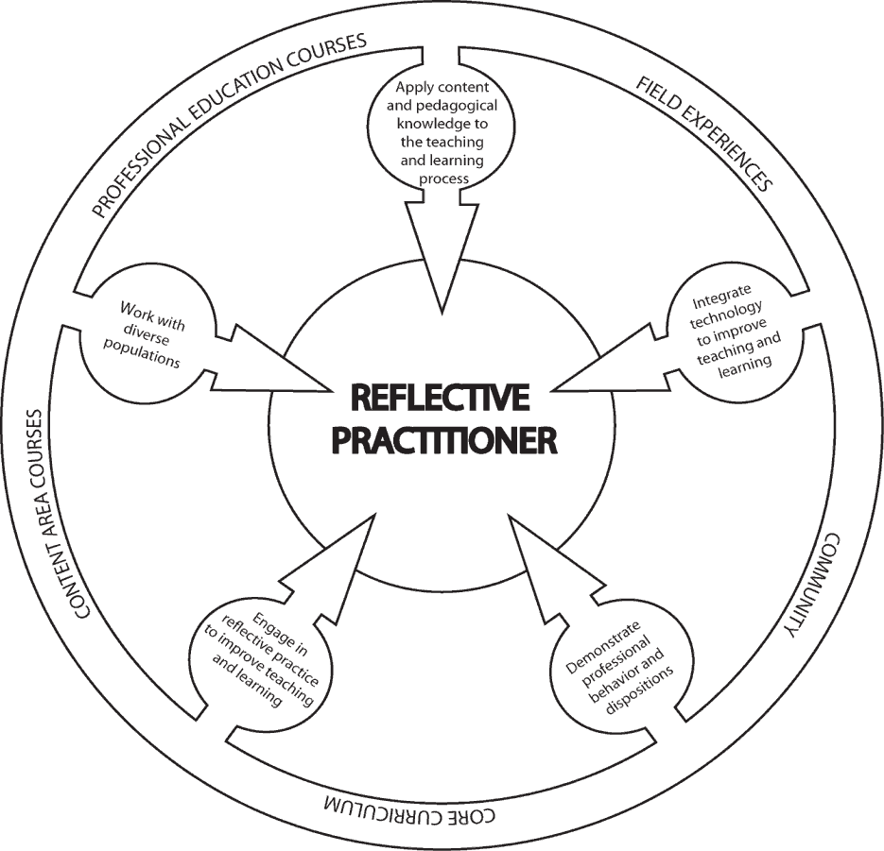
The overarching theme of the Conceptual Framework for all educator preparation programs is "The Educator as Reflective Practitioner." The initial and advanced teacher education programs and the advanced program in educational leadership focus on the development of knowledge, skills, and professional dispositions to ensure that all candidates are well prepared and meet all institutional, state, and professional standards at the completion of their program. The Conceptual Framework describes the shared vision of teaching, learning, and the preparation of teachers and school leaders. It outlines our philosophy and commitment to the education profession; guides programmatic decisions; and ensures coherence among curricula, field experiences, clinical practice, and the unit’s assessment system. The Conceptual Framework reflects our commitment to integrate technology, demonstrate professional behavior and dispositions, engage in reflective practice, work with diverse populations, and apply content and pedagogical knowledge to the teaching and learning process.

Unit Assessments and SPA Assessments

No SPA assessments are required for this course; however, this course aligns with the standards for teacher licensure/certification in special education established by CAEP and the Council for Exceptional Children (CEC), the major special education professional organization in the United States, which is the Specialized Professional Association (SPA) for special education.

Standards Alignment Information:

CF = Conceptual Framework & Candidate Proficiencies (2010)
CEC = Council for Exceptional Children [Specialized Professional Association (SPA)] Content Standards
APS=ADEPT Performance Standards for classroom-based teachers
InTASC = Interstate Teacher Assessment and Support Consortium ISTE-E = International Society for Technology in Education

Student Learning Outcomes | Alignment
Students who successfully complete EDSP 470 should be
able to:
Use person- first language when discussing people with disabilities. | CF: 3.1  CEC: 6  APS 10
Define emotional and behavioral disabilities and models that describe deviance; | CF: 3.1  CEC: BD1K1-K4
Describe the historical development, philosophies, theories of reinforcement techniques, and models related to the field of emotional/behavior disabilities and implications for current practice. | CF: 3.1 CEC: BD1K5-6  APS 6
Identify and describe etiology and diagnosis of EBD including various facets of EBD related to various theoretical approaches for students with emotional/behavioral disabilities. | CF: 3.1, 4.1, 4.3,5.2 CEC: BD2K1-3  APS 6
Describe policies and procedures involved in the screening, diagnosis, and placement of individuals with emotional/ behavioral disorders including academic and social behaviors as well as identifying prevention and intervention strategies for students at risk | CF: 3.2  CEC: BD8K2; BD4K4  APS 5; 6
Identify EBPs and model programs for individuals with EBD. | CF: 5.2 CEC: BD4K5; BD7K1  APS 6
Prepare lesson plans that include instructional strategies and adaptations for students with emotional disabilities in both general (math, science, social studies, English, etc.) and special education classroom environments. | CF: 1.1, 1.2, 1.3, 2.1, 3.1,  3.2, 4.1, 4.2, 4.3  CEC: 2, 3, 4, 5, 7  APS: 1, 2, 6  InTASC: 1, 2, 3, 4, 5, 7, 8  ISTE: 5,7
9. Research effective practices in curriculum strategies that correspond with South Carolina Curriculum and Learning Standards, and the SC Education and Economic Development Act | CF: 1.2, 3.2, 4.3, 5.1  CEC: 3, 4, 7, 10  APS: 1, 2, 5, 10  InTASC: 7, 8, 10
10. Use evaluation, planning and management procedures to match learner needs with instructional environments and methods, including accommodations and modifications | CF: 1.2, 1.3, 2.1, 3.1, 3.2,  4.1, 4.3  CEC: 3,4,5,7  APS: 8, 9

Field Experience assigned to this course: There is no field experience connected to this course. However, one or more assignments may require pre-service candidates to work with children and/or teachers in an educational setting.

Policies
Academic Integrity Statement
Coastal Carolina University is an academic community that expects the highest standards of honesty, integrity and personal responsibility. Members of this community are accountable for their actions and are committed to creating an atmosphere of mutual respect and trust.

Honor Pledge: (required of all entering CCU students)
On my honor, I pledge:
    - That I will take responsibility for my personal behavior; and
    - That I will actively oppose every instance of academic dishonesty as defined in the Code of Student Conduct.
From this day forward, my signature on any University document, including tests, papers and other work submitted for a grade is a confirmation of this honor pledge.

Attendance
Students are expected to attend all parts of all classes, actively participate in all classes, demonstrate professional behavior in the classroom, and complete all assignments with professional quality and in a timely manner. When absence from class is unavoidable, students are responsible for getting all class information (e.g., handouts, announcements, notes, syllabus revisions) from another class member prior to the class meeting that follows the absence. A candidate who misses more than two classes will drop one letter grade. The grade of F will be assigned for absences in excess of 25% of the regularly scheduled class meetings.

Written documentation is needed to confirm any and all excused absences such as: a recognized emergency or from a serious illness. It is the responsibility of each student to assume the loss of instruction when not in attendance. It is also the sole responsibility of each student to obtain and missed instructional materials and/or notes. It is advisable that you designate another classmate to collect your materials in your absence. Please note that the Coastal Carolina University catalog states that an instructor is permitted to assign an F to a student with unexcused absences in excess of 25% of regularly scheduled class meetings. Please see the LiveWell@Coastal program for matters both personal and academic that may prevent you from completing your course responsibilities: https://www.coastal.edu/services/studenthealth/healtheducation/livewellccu/

Inclement Weather Policy for EDSP 470
In the event of hazardous weather, faculty, staff, and students are requested to listen to local radio and television stations or visit the Coastal Carolina University website for official University closing announcements. Announcements about hazardous weather are also posted on the University’s homepage. Review the Hazardous Weather and Emergency Conditions Leave Policy (FAST-HREO- 220). Instructors may refer to the Contingency Instruction website or Section VIII N. Contingency Instruction for information about what to do if class has been cancelled.

In the event that the university is closed due to poor weather conditions, log onto the Moodle Course page for EDSP 470 and check for any directions from Dr. Hollis. Remember to upload any assignments that are due for that session to avoid a deduction of points for lateness.
Support for Candidates with Disabilities

Coastal Carolina University is committed to equitable access and inclusion of individuals with disabilities in accordance with the Americans with Disabilities Act and Section 504 of the Rehabilitation Act. Individuals seeking reasonable accommodations should contact Accessibility & Disability Services (843-349-2503 or https://www.coastal.edu/disabilityservices/).

Student Services
Academic Support:
Link to Learning Assistance Center Link to Kimbel Library Website Link to Counseling Services
Link to online orientation

Technology Support
Link to Technical Support from Student Computing Services
Link to A list of on-campus HelpDesks and the Help Request Form

Other Student Services
Link to Office of the Registrar
Link to Financial Aid and Scholarships Link to Student Activities and Leadership Link to Dean of Students Office

Course Objectives
This course is designed to prepare prospective teachers to:
- Discuss key concepts and issues associated with current definitions of emotional/behavioral disorders.
- Discuss the historical foundations of educational services for students with emotional/behavioral disorders.
- Identify and describe characteristics displayed by students with emotional/behavioral disorders.
- Discuss major etiological theories for emotional/behavioral disorders.
- Describe the assessment procedures and criteria used for establishing the presence of an emotional/behavioral disorder.
- Describe different types of emotional/behavioral disorders.
- Describe the current status of programs and services for students with emotional/behavioral disorders.
- Describe the roles and responsibilities of individuals normally involved in identifying and providing educational programs and support services for students with emotional/behavioral disorders.
- Identify sources of unique services, networks, websites, and organizations relevant to emotional/behavioral disorders.
- Discuss family issues related to emotional/behavioral disorders.
- Identify EBPs related to emotional disabilities.

Course Requirements/Grading

Grading: Grades will be based on the total points accumulated by the student. A total of 270 points are divided over the following course requirements:

Assessments | Maximum Point values*
Article Critique | 25
Final exam/project | 50
Evidenced Based (Academic and Behavior Support) Practice Project | 50
EBD Project/Activity | 25
Intersection of Race and Disability | 50
Lesson plan | 15
Class Participation (2 @ 15 weeks) | 30
Book Activity/Reflection | 25
MAXIMUM POINTS POSSIBLE | 270

*Point values subject to change as specific assessment tools are developed.
Course grades: Grades will be calculated as a percentage of possible points earned for course assignments and exams.

Grading Procedures (percentage of possible points)
A | 93-100% | C | 77-81%
B+ | 90-92% | D+ | 74-76%
B | 85-89% | D | 69-73%
C+ | 82-84% | F | 0-68%

Course Procedures
Class Engagement and Professional Dispositions
As professional educators, your students are entitled to be served by professionals prepared with knowledge you will gain in this course. Students in this course are expected to conduct themselves in a professional manner in relationship to the opinions, ideas, and values of fellow classmates.
Examples of in-class behaviors that are unprofessional include: (a) carrying on side conversations during class instruction and/or while another individual is speaking, (b) arriving late to class and disrupting others already engaged in the session’s activities, (c) attending class unprepared, causing a lack of meaningful participation and/or effort on the part of the student, and (d) texting/ emailing/browsing the internet during class.

Late Assignments
For each late assignment, ten percent of the total point value of the assignment will be deducted from the total points available per week after the due date until it is turned in. An assignment is considered "late" if it is not submitted by the time and date it is due. Dr. Hollis will allow one assignment from each student to be submitted late without penalty. If you choose to use the late assignment option, it is then critical that you submit a document stating that you are using your one free late assignment. Then, the assignment MUST be submitted by the NEW due date which would be exactly one week from the original due date.
Example:
Total possible points for assignment | 20
Earned score | 17
Submitted one class session late | -2 (10% of total possible score)
Final score | 15/20

Extra Credit

Please do not request extra credit work, as each assignment for this course was carefully designed to stimulate specific learning experiences among students that superfluous assignments cannot replace nor fulfill.

Communication with the Professor

    - Routine access (daily) to CCU email and Moodle for communication and assignments is crucial to participation in this class.
    - Please come see me in my office during office hours if we need to discuss anything.
    - If your question can be solved through a simple email, please email me with the course name (EDSP 470) in the subject line. I should respond to you within 24 hours unless I am out of town at a conference which may cause a longer response time.

Journals consulted and reviewed on a regular basis

Behavior Disorders
Career Development for Exceptional Individuals Education & Treatment of Children
Exceptional Children
Focus on Exceptional Children
Intellectual and Developmental Disabilities Intervention in School and Clinic
Preventing School Failure
Journal of Applied Behavior Analysis
Journal of Autism and Developmental Disorders Learning Disabilities Quarterly
Remedial and Special Education
Teacher Education and Special Education TEACHING Exceptional Children
The Journal of Special Education

Additional Online Resources

- South Carolina State Department of Education: http://ed.sc.gov
- Horry County Schools: http://www.horrycountyschools.net/
- Wrightslaw: www.wrightslaw.com
- LD Online: www.ldonline.org
- CEEDAR Center: http://ceedar.education.ufl.edu/
- Council for Learning Disabilities: https://council-for-learning-disabilities.org/
- American Institutes for Research (Special Education): http://www.air.org/focus- area/education/?id=9
- National Association of Special Education Teachers: http://www.naset.org/
- Council for Exceptional Children: www.cec.sped.org
- National Dissemination Center for Children with Disabilities: www.nichcy.org
- Center for Effective Collaboration and Practice: http://cecp.air.org/

